**Project – Music Data Analysis**

**Kapil Goyal**

**Introduction:**

A leading music-catering company is planning to analyze large amount of data received from varieties of sources, namely mobile app and website to track the behavior of users, classify users, calculate royalties associated with the song and make appropriate business strategies. The file server receives data files periodically after every 3 hours.

**Data-set:**

**Google Drive Link:**

https://drive.google.com/drive/folders/0B_P3pWagdIrrMjJGVlNsSUEtbG8?usp=sharing

**Data Description**

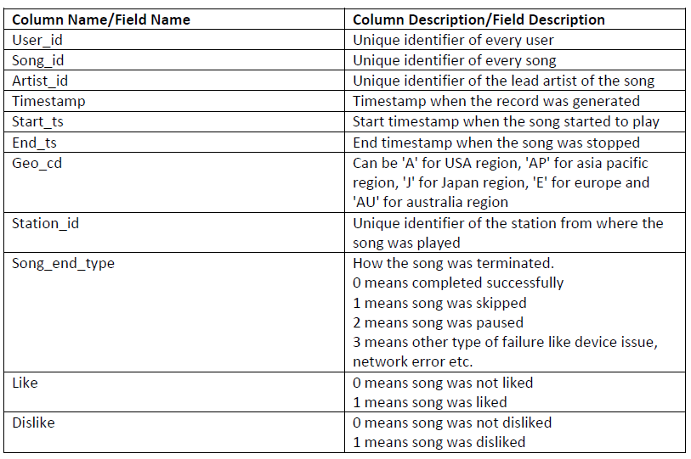

**Data Files:**

Below is the data coming from web applications, that reside in /data/web and has **xml** format

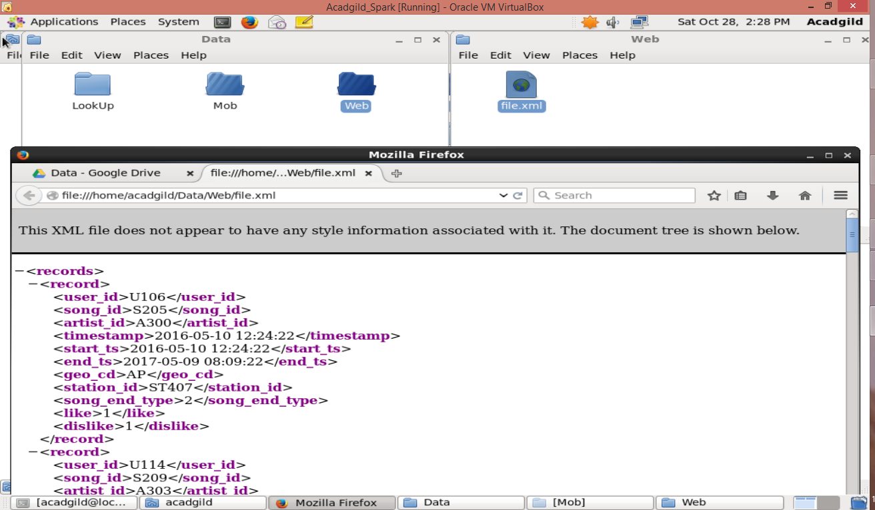

Below is a sample of the data coming from mobile applications, that reside in /data/mob and has **csv** format.

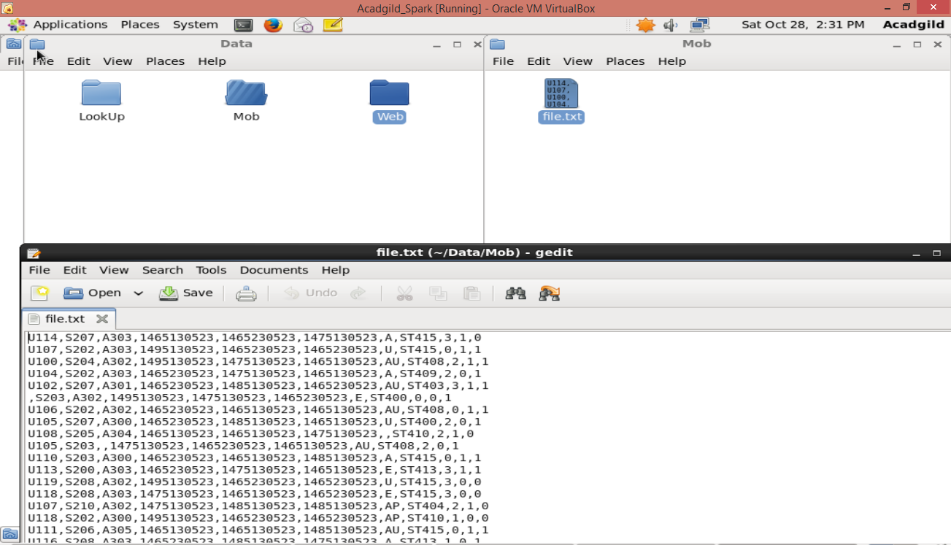

**Look-Up Tables Files:**

There are some existing lookup tables present in NoSQL Databases that play an important role in

data enrichment and analysis.

This data is present in lookup directory and loaded in HBase.

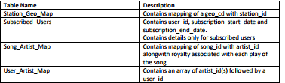

Below are the data to be present in the lookup tables. There are 4 tables:

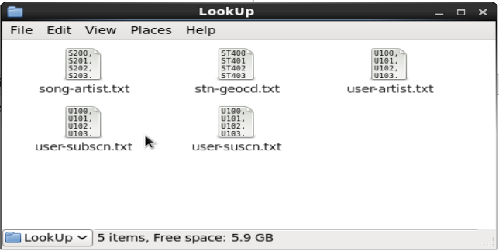

**song-artist**

Columns: **song_id**, **artist_id**

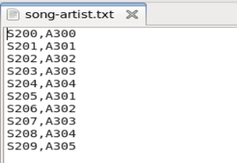

**stn-geocd**

Columns: **station_id, geo_cd**

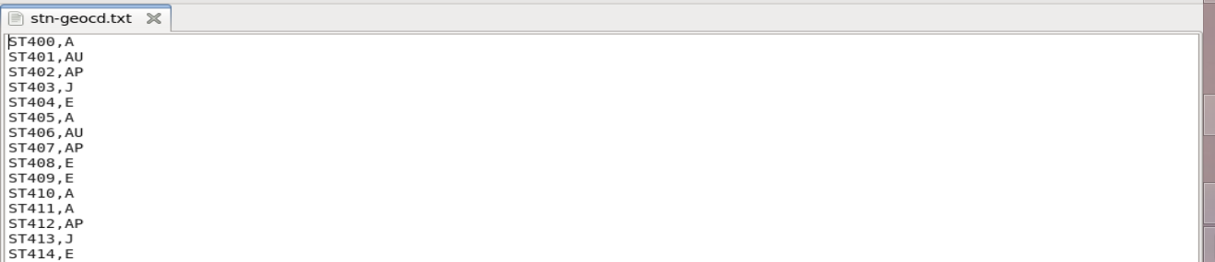

**user-artist**

Columns: **user_id, artists_array**

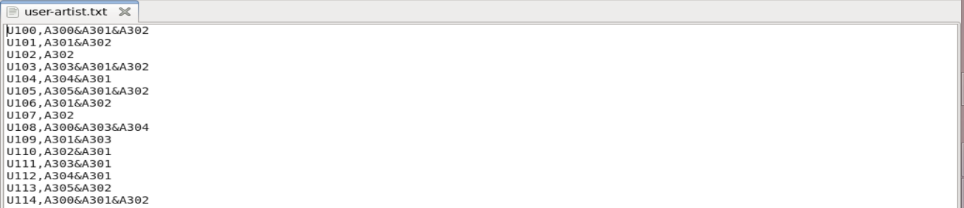

**user-subscn**

Columns: **user_id**, **subscn_start_dt, subscn_end_dt**

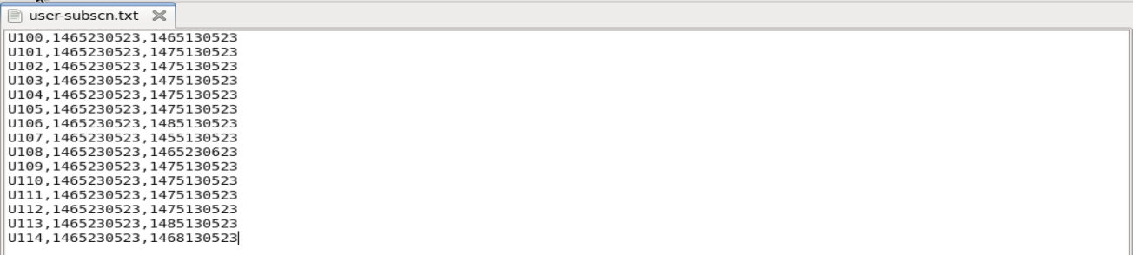

**Steps to perform data analysis on the Music Data:**

**Step 1:** Launch all necessary daemons

**Step 2:** Start Job Scheduling (using Crontab)

**Step 3:** Populate Look-Up tables (i.e. Load all data to HBase)

**Step 4:** Perform Data Formatting (using Pig and Hive)

**Step 5:** Perform Data Enrichment and Cleaning (using Hive)

**Step 6:** Perform Data Analysis (using Spark)

**Step 1:**

Launch all necessary daemons

* Launch the Mysql Service (needed for Hive)
* Give permissions to scripts folder in project, so we are able to run scripts from the bash shell.
* Run the shell script start-daemons.sh

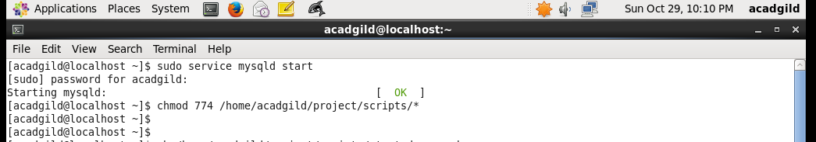

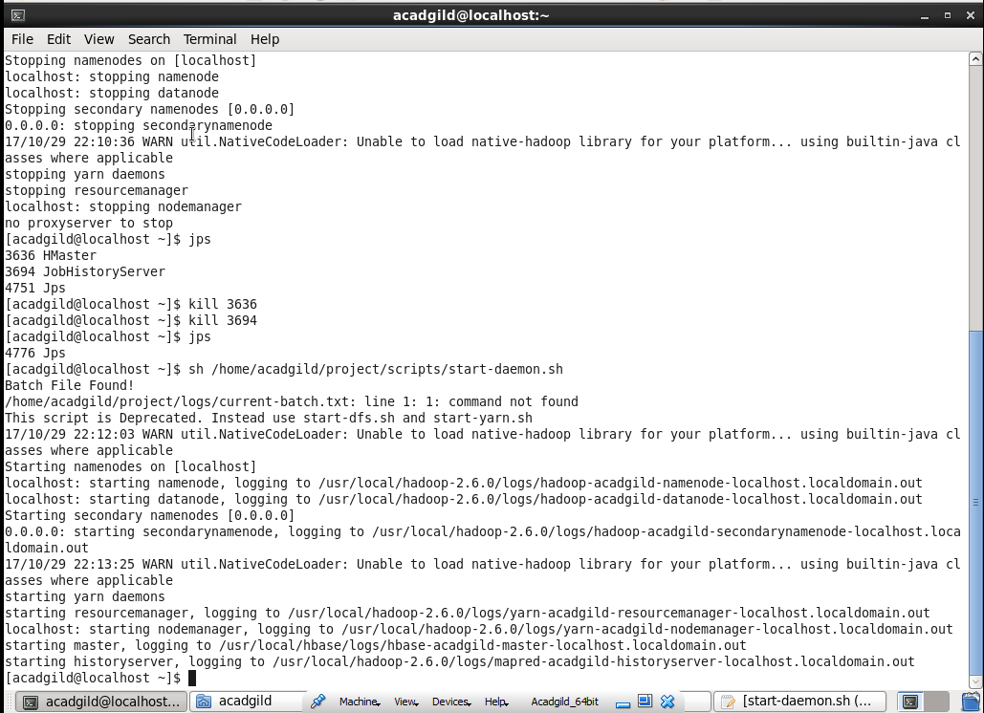

In the shell script start-daemons.sh used above, we perform the following operations: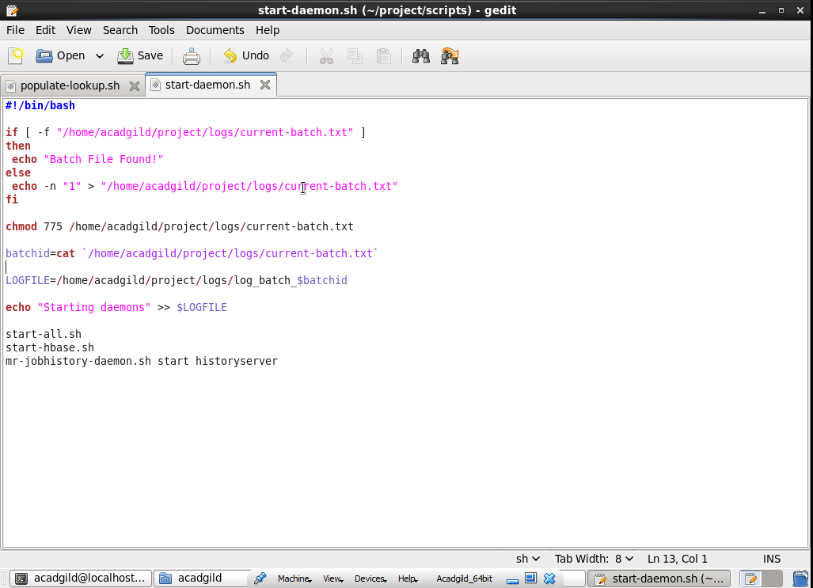

Check if a file **current-batch.txt** has been created or not,

If already created, print **Batch File Found!** else create the file and add 1 to it to signify

batch 1.



Give permissions to the file, so that we are able to modify it on the run.

➢ Get the batch id number from the batch file created above and create a **Log File** for the

batch using the batch id. This will be **log_batch_1**.

Through out the course of the analysis process this log file will document the tasks that

are performed for the Music Data Analysis.

➢ Add a log to the Log File signifying that the all necessary daemons have been started.



**Step 2:**

Start Job Scheduling

➢ Open the crontab file and insert the statement:

* */3 * * * /home/acadgild/project/scripts/wrapper.sh

Crontab is used for Job Scheduling. In the -e mode, Crontab schedules execution of

commands by a regular user.

The statement above runs the wrapper.sh shell script every 3 hours.



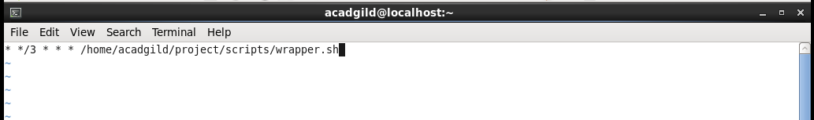

In the shell script wrapper.sh used above, all the processes needed to perform analysis on the

Music Data is called once every 3 hours thereby creating a new batch. This is the job scheduling.

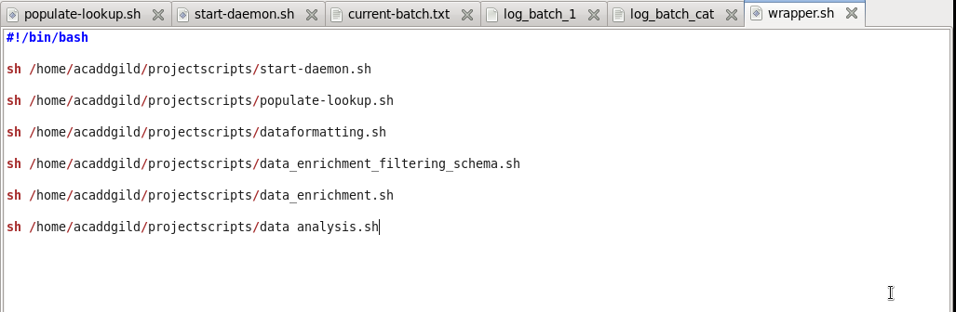

**Step 3:**

Populate Look-Up tables

Below is the shell script populate-lookup.sh that is used to load the data for the lookup

tables into HBase tables.

The following operations are performed:

➢ Get the batch id number from the batch file and get the **Log File** for the batch using the

batch id. This will be **log_batch_1**

➢ Add logs to the Log File signifying that the lookup tables are being created and populated

➢ Create the HBase tables for the lookup data files: **song-artist**, **stn-geocd** and **user-subscn**

with their column families

➢ For every lookup data file, read each line, extract the columns (comma separated) and add

the data as rows to the corresponding HBase tables created above

➢ Run the hive script user-artist.hql. This will populate a hive table with the data in the

lookup data file **user-artist**. This is because this file has an array column that is difficult to

populate in HBase.

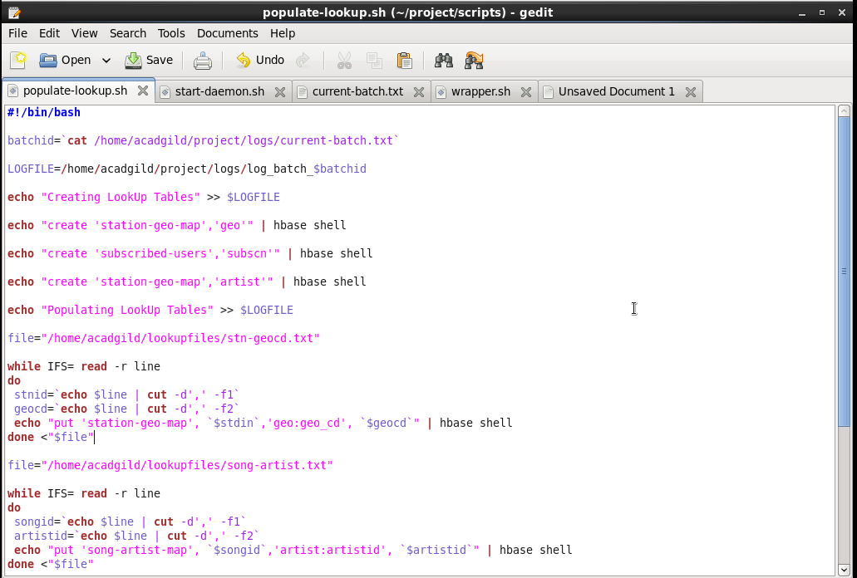 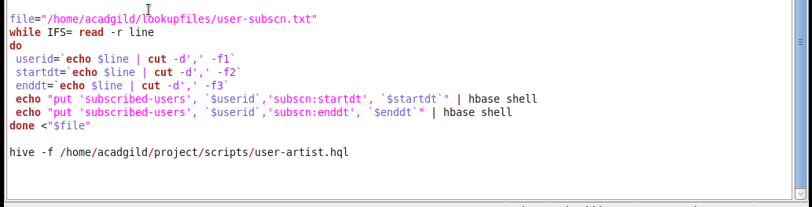

After the data in **user-artist** is loaded in the Hive Table **users-artists**, it is then saved as a

text file as below (for data analysis using spark)

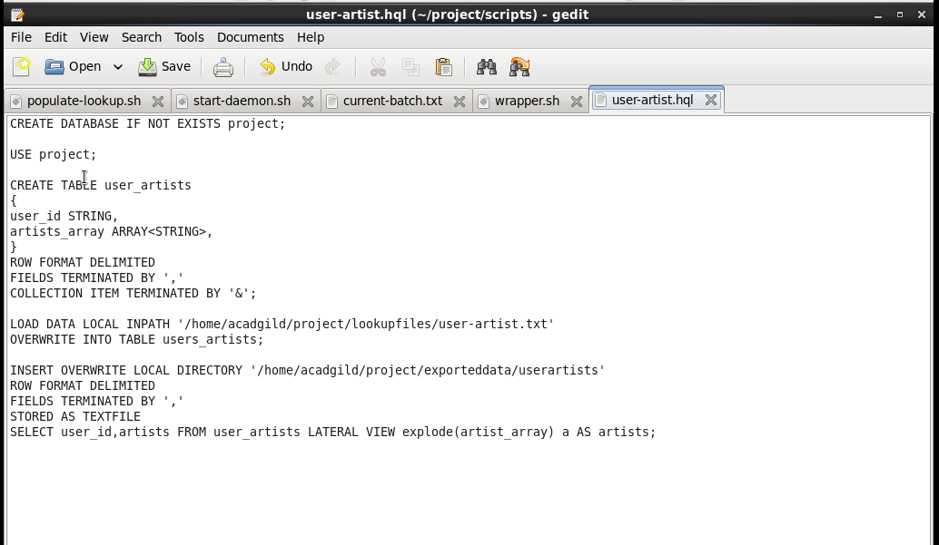

Below is a view of the execution of the above:

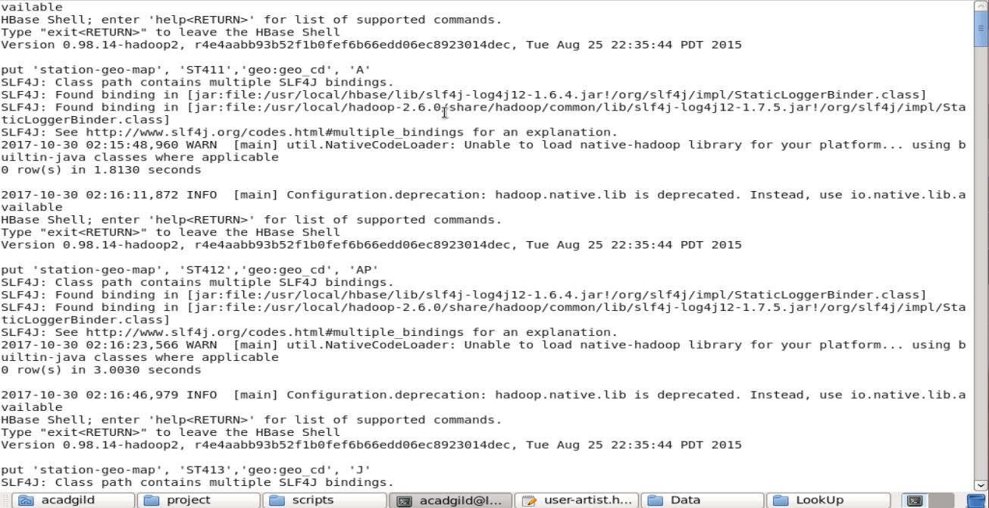

Output of the above (HBase):

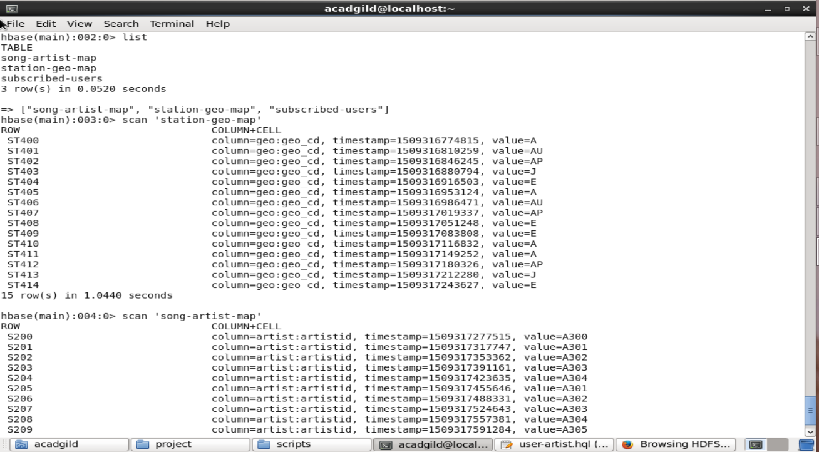

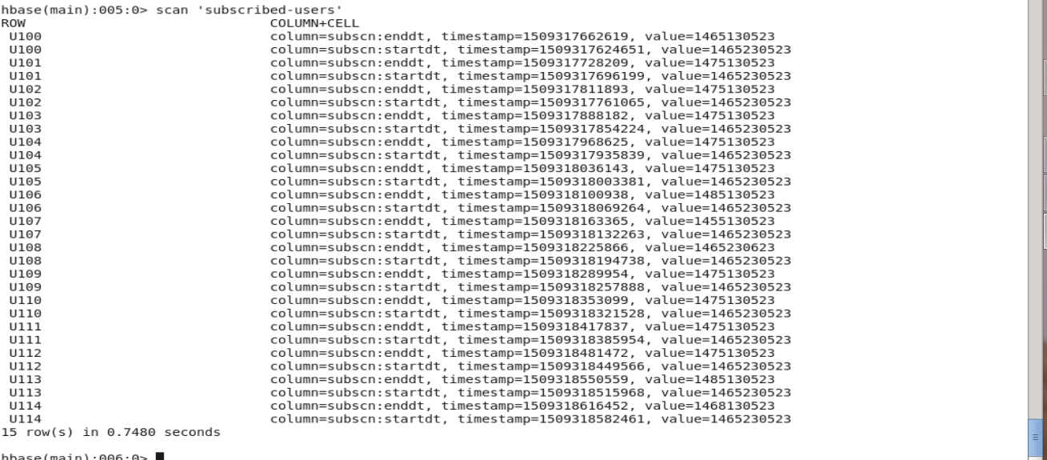

Output of the above (Hive):

The data in the hive table (exploded) that was saved:

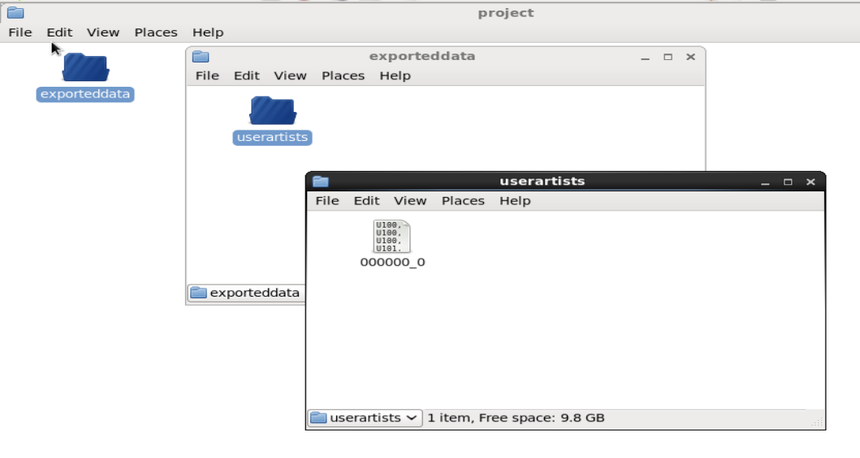

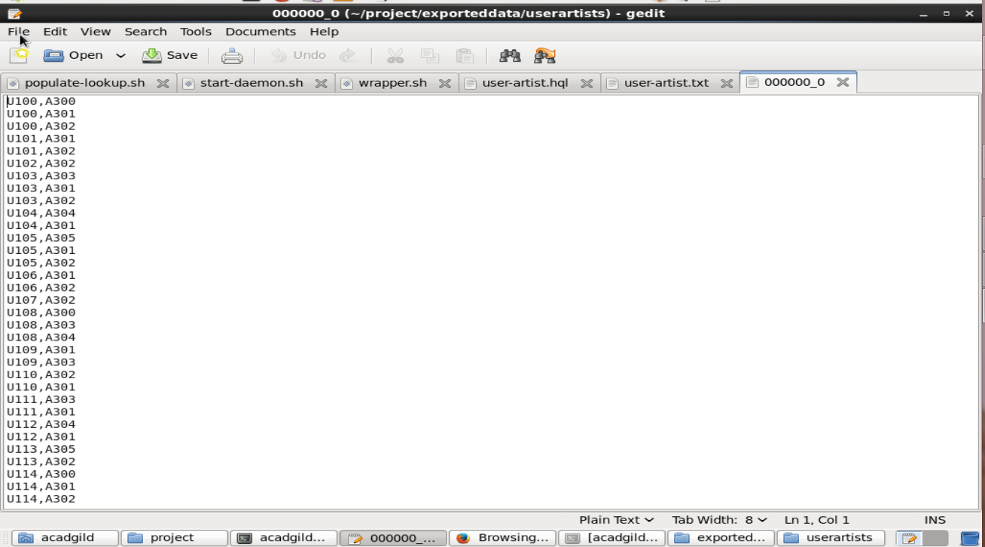

**Step 4:**

Perform Data Formatting

Below is the shell script dataformatting.sh that is used to:

➢ Format the web xml data using **Pig** to a csv fomat *and*

➢ Load the 2 data files, **mob** and **web** (formatted by Pig), to a Hive Table for data enrichment

The following operations are performed:

➢ Get the batch id number from the batch file and get the **Log File** for the batch using the

batch id. This will be **log_batch_1**

➢ Add logs to the Log File signifying that the data is placed in the HDFS and the running of

the Pig and Hive scripts for data formatting and loading respectively.

➢ Delete, if they exist, folders for the mob, web and formattedweb. This is done in-case any

old data remains because of execution failure.

➢ Create the above folders web and mob that were deleted above and move the data from the

Local FS to the HDFS. The formattedweb folder is created in the Pig Script.

➢ Run the pig script dataformatting.pig. This will format the web data (stored in the

web folder in the HDFS) in xml format to csv format and store it in the HDFS in the folder

formattedweb.

➢ Run the hive script formatted_hive_load.hql. This will load the data in the mob

folder and formattedweb folder in the HDFS to a table formatted_input in Hive which will

be used for data enrichment later.

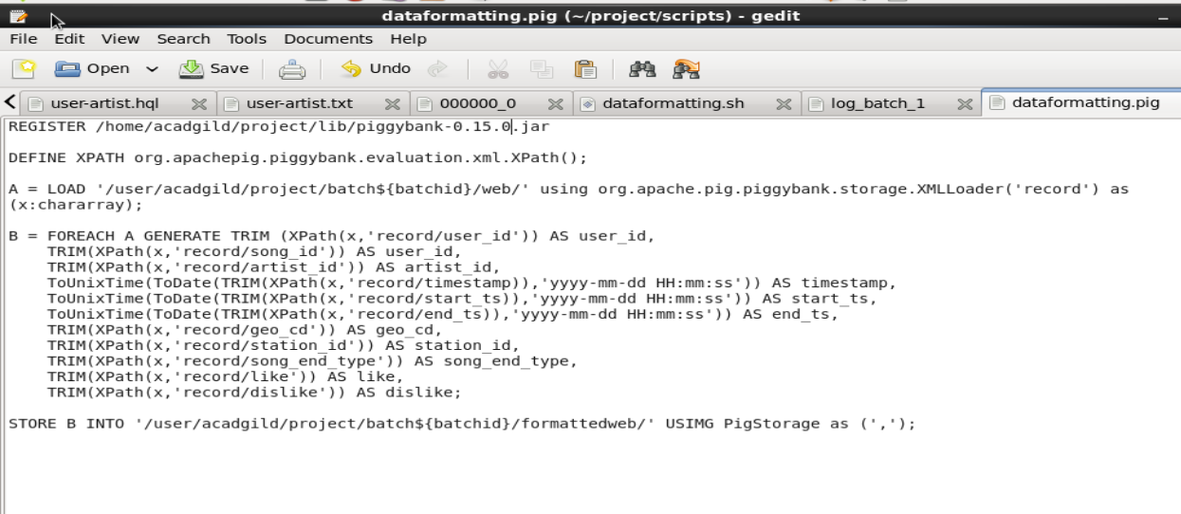

**formatted_hive_load.hql**

Combines the data from mob and formattedweb to make one data-set and stores it partitioned by batchid.

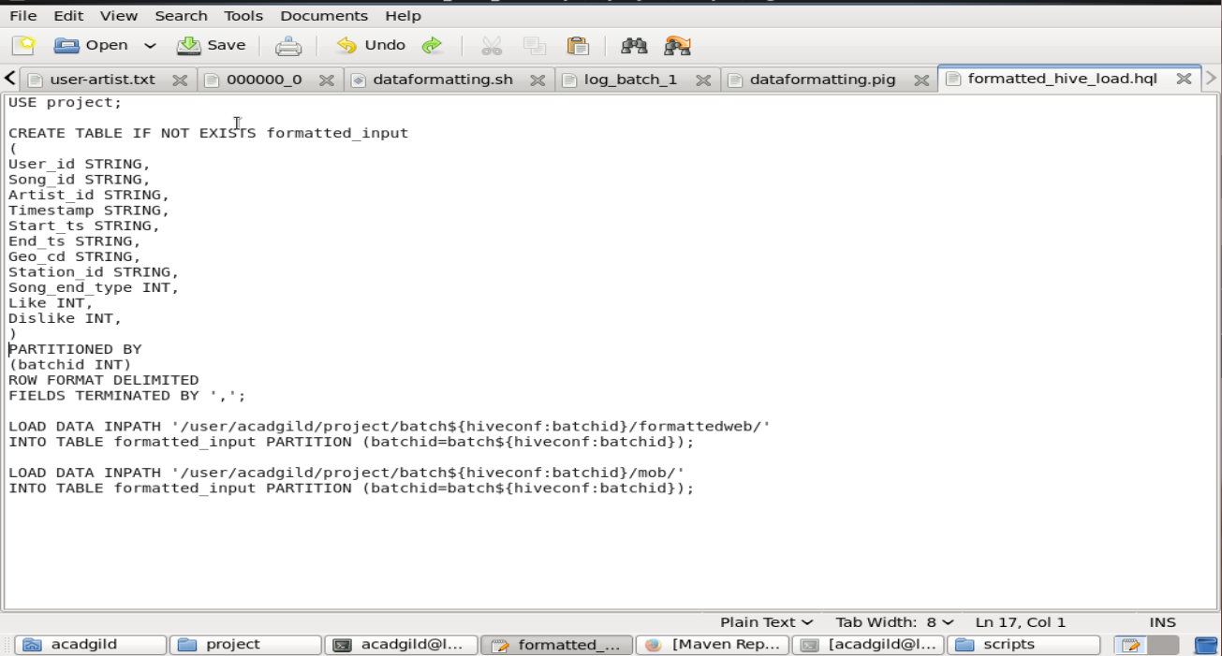

Below is a view of the execution of the above:

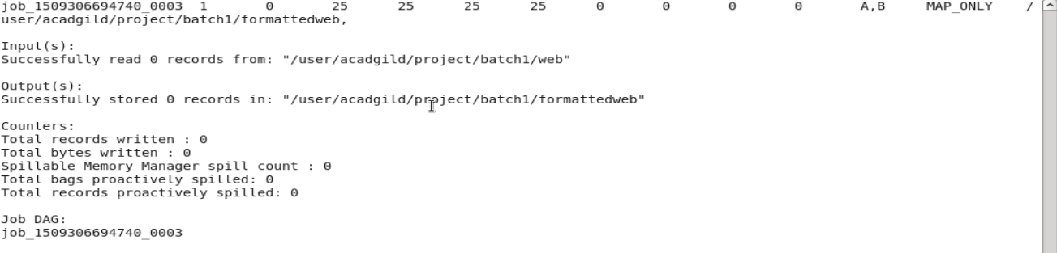

Below is a look at the data in the table **formatted_input**:

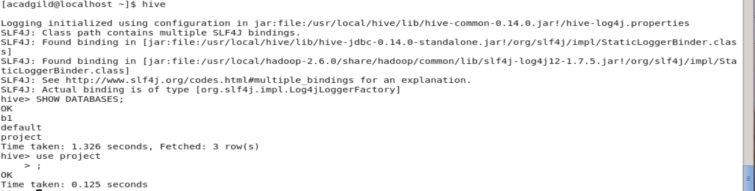

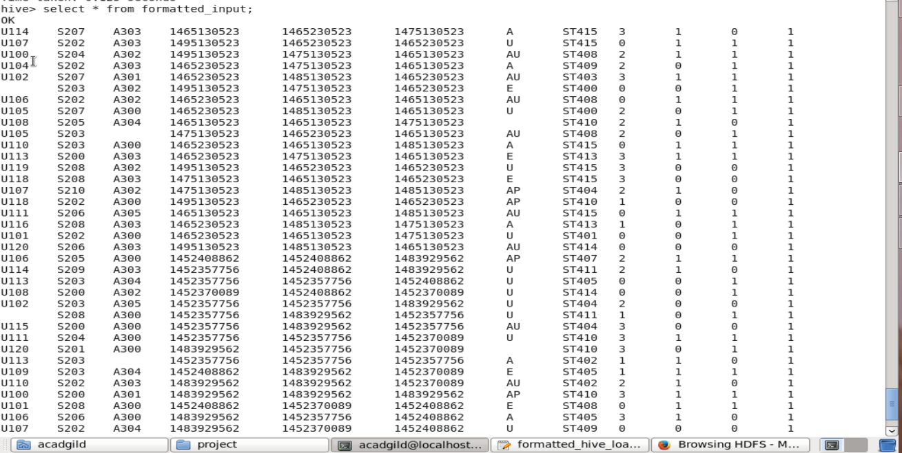

Below is a look at the data in the table **formatted_input** in the hive warehouse:

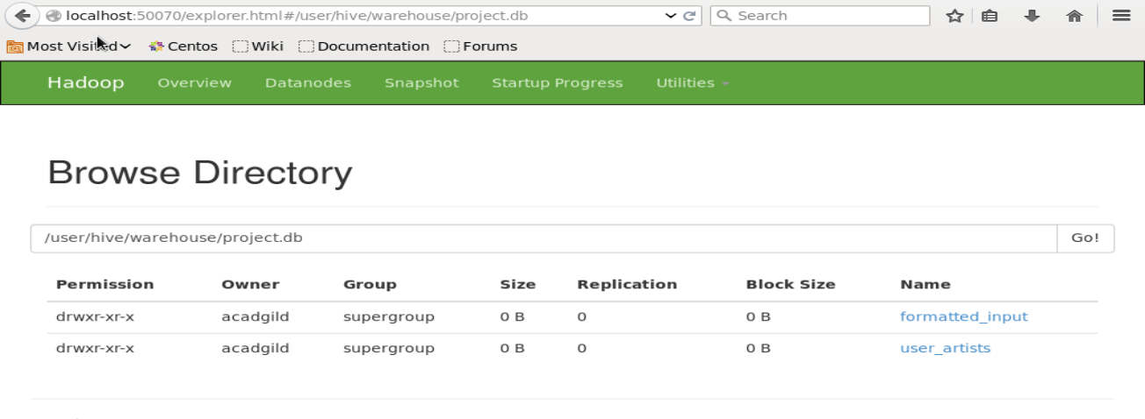

**Step 5:**

Perform Data Enrichment and Cleaning

The data enrichment is carried out in two steps:

➢ Create lookup tables in Hive and import the data from the HBase lookup tables to them. This

is done by shell script data_enrichment_filtering_schema.sh

➢ Perform the data enrichment to the data in formatted_input using the lookup tables. This is

done by shell script data_enrichment.sh

**1) data_enrichment_filtering_schema.sh**

Below is the shell script data_enrichment_filtering_schema.sh where the

following operations are performed:

➢ Get the batch id number from the batch file and get the **Log File** for the batch using the

batch id. This will be **log_batch_1**

➢ Add logs to the Log File signifying that the Hive lookup tables are created from the

HBase lookup tables.

➢ Run the hive script create_hive_hbase_lookup.hql. This will create the lookup

tables in Hive and import the data from the HBase lookup tables to the Hive lookup

tables.

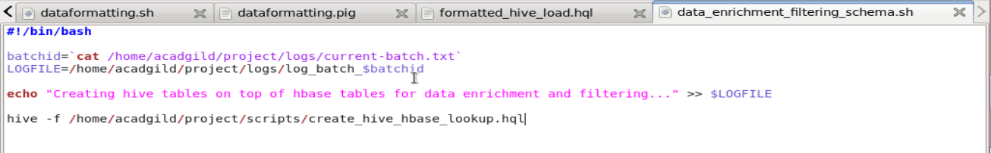

**create_hive_hbase_lookup.hql**

Create Hive lookup tables and save lookup table **subscribed_users** to Local FS.

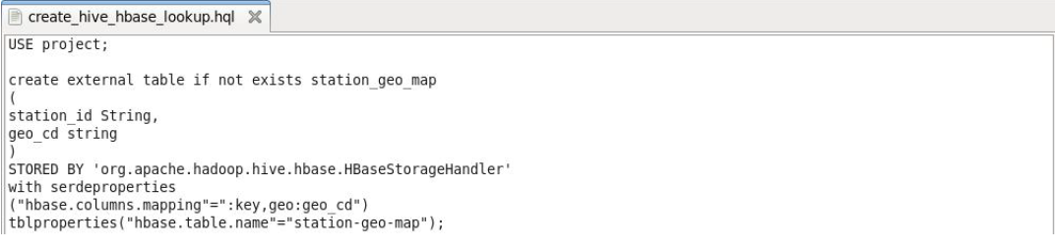

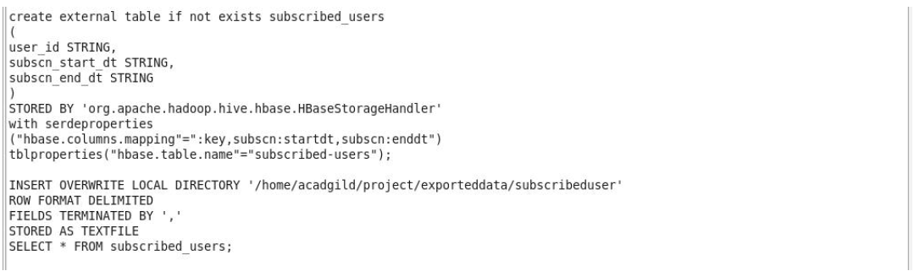

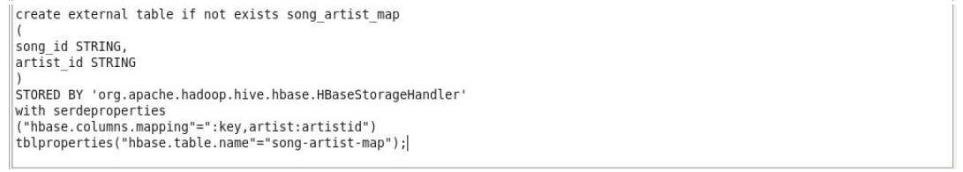

Below is a view of the execution of the above:

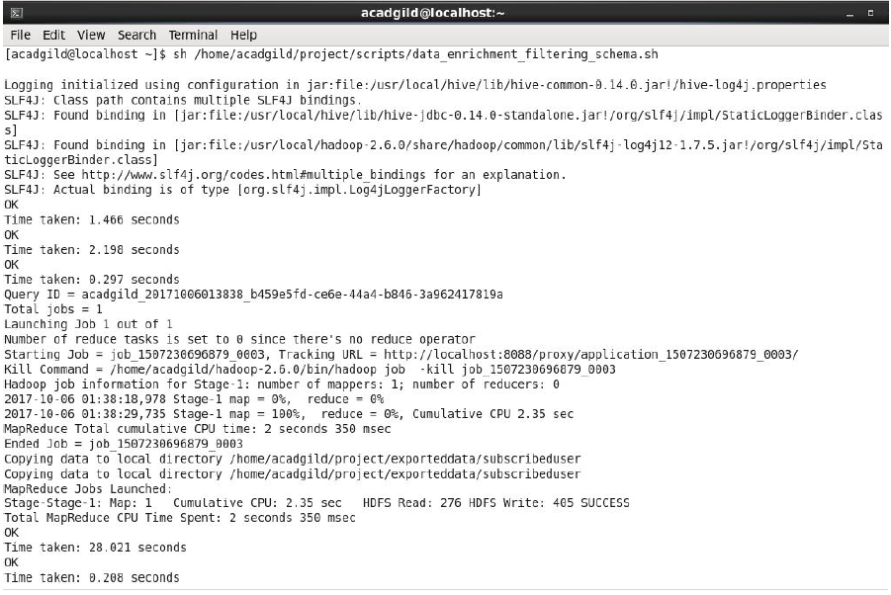

**Output of the saved table subscribed_users in the Local FS:**

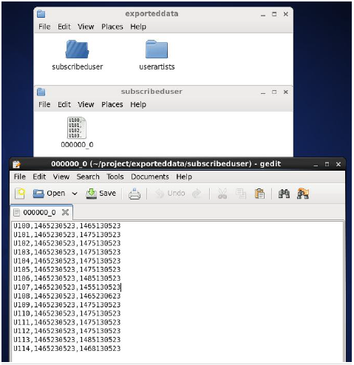

**Output in Hive:**

The tables were created and populated as intended.

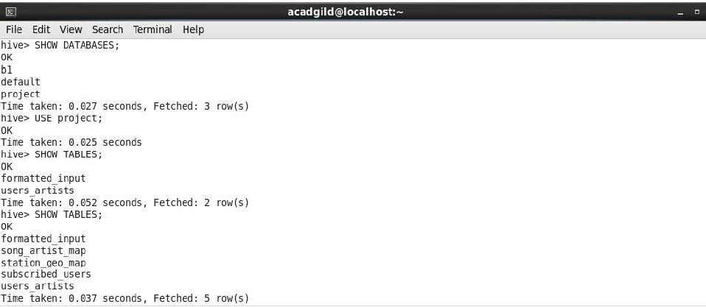

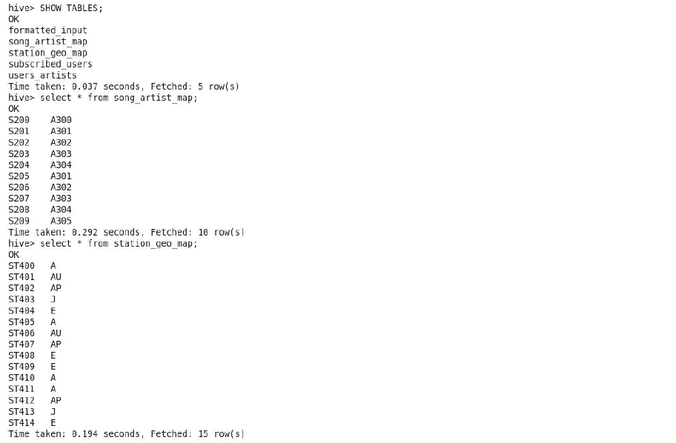

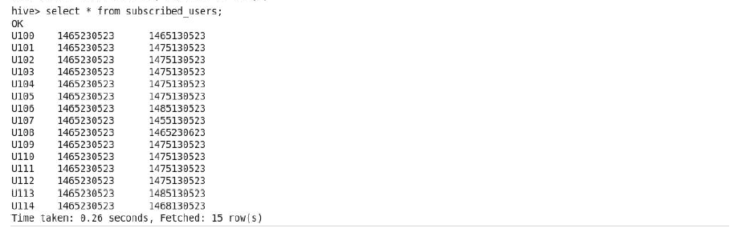

**2) data_enrichment.sh**

Below is the shell script data_enrichment.sh where the following operations are

performed:

➢ Get the batch id number from the batch file and get the **Log File** for the batch using

the batch id. This will be **log_batch_1**.

➢ Add logs to the Log File signifying that the data enrichment has begun.

➢ Run the hive script data_enrichment.hql. This will create a Hive table

**enriched_data** that will hold the data that is enriched and partitioned based on given

rules as pass or fail (status) and batchid.

➢ Add logs to the Log File signifying that the valid and invalid outputs are being

recorded in their respective folders.

➢ Copy the data from the pass and fail folders (valid & invalid) in the Hive warehouse to

the Local FS.

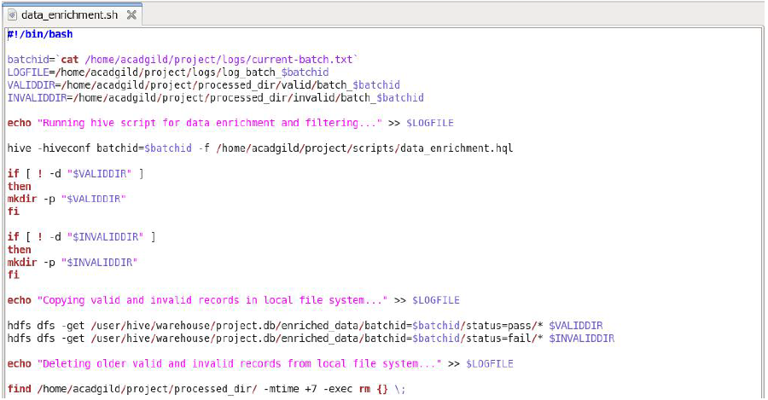

**data_enrichment.hql**

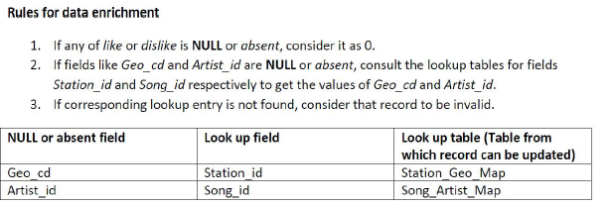

For the data enrichment, a table **enriched_data** is created and the table is overwritten with the

result of the below operations:

➢ The data in the **formatted_input** table is joined with the lookup tables **station_geo_map**

and **song_artist_map** to fill in the data gaps that can be obtained by said tables.

*and*

➢ The same data is then filtered by the rules given above and partitioned by status (pass or fail)

& batchid.

The data of the enriched_data table is then stored in a folder in the Local FS.

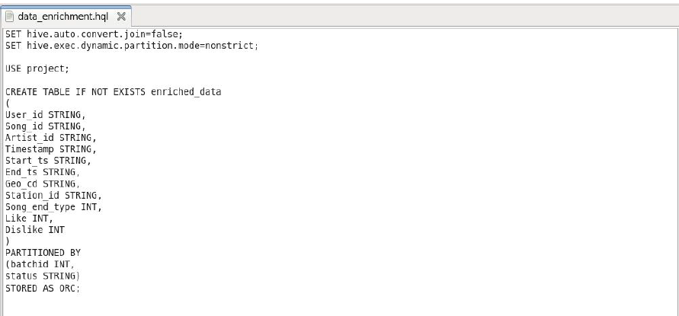

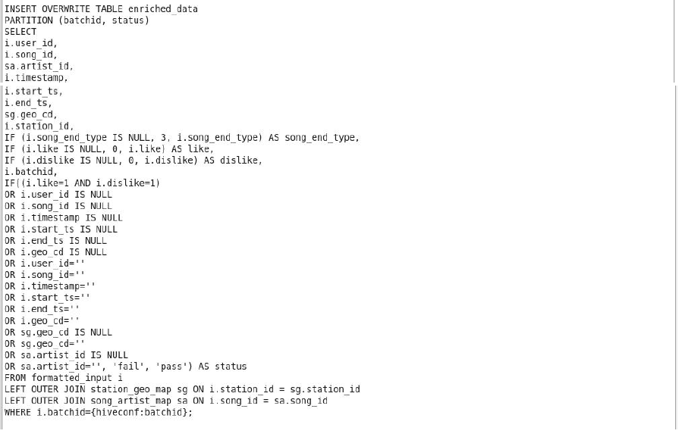

**Output in Hive :**

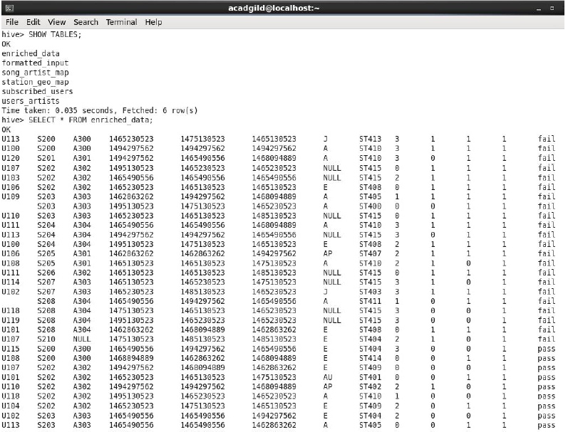

**Output saved in the Local FS:**

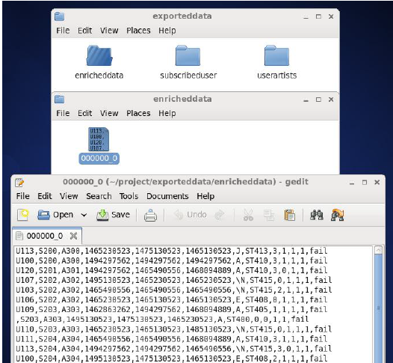

**Step 6:**

Perform Data Analysis

Below is the shell script data_analysis.sh where the following operations are

performed:

➢ Get the batch id number from the batch file and get the **Log File** for the batch using the

batch id. This will be **log_batch_1**

➢ Add logs to the Log File signifying that the data analysis is being performed using Spark

and that the result is being exported to the Local FS.

➢ Run the spark script data_analysis.scala. This will perform the data analysis required

in the problem statement given and save the result to the Local FS.

➢ Add logs to the Log File signifying that the data analysis has completed and that the batch is

being incremented. Here from 1 to 2

➢ Get batchid number from batch file and increment the batchid by 1.

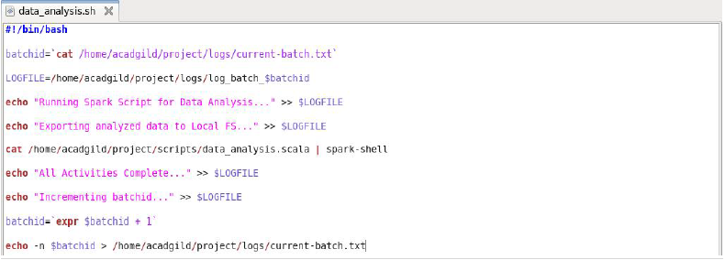

Below is the file **data_analysis.scala** that will perform the data analysis for the given problem

statements on the enriched_data that was saved to the Local FS.

**Initialization:**

➢ Import Row, DataFrame, Structure type and function dependencies needed to perform

analysis.

➢ Get the batchid from the batch file and store it in the variable **batid**

➢ Get the data that was exported and saved in the Local FS from the steps above i.e.

enriched_data, subscribed_user and user_artists and perform the foll. on each of them:

➢ Create the schema for the data

➢ Create a DataFrame from the schema and data

➢ Create a temporary table from the DataFrame created

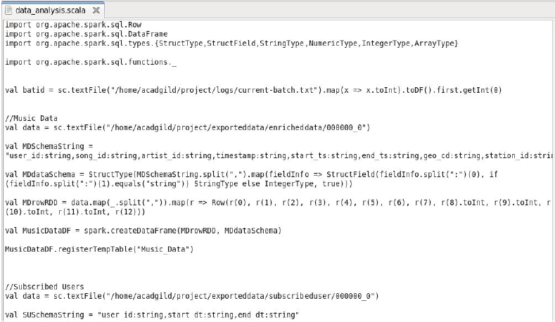

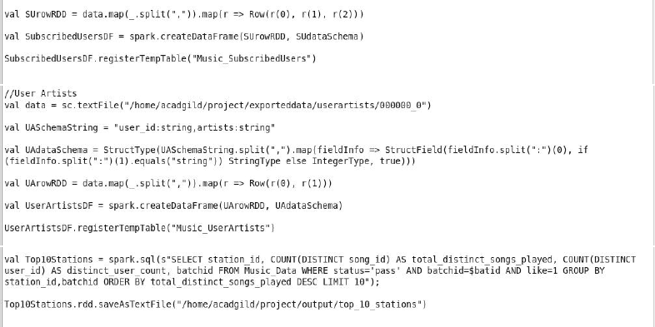

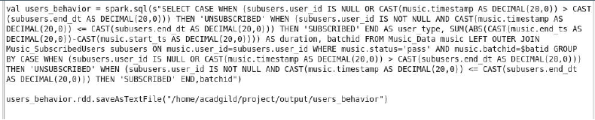

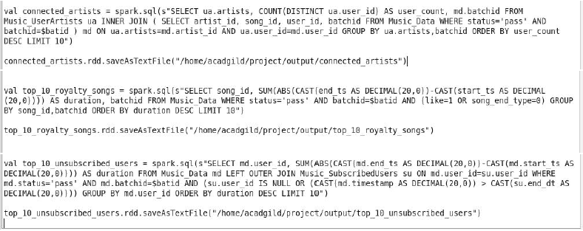

**Problem Statements:**

➢ Determine top 10 station_id(s) where maximum number of songs were played, which were

liked by unique users.

➢ Determine total duration of songs played by each type of user, where type of user can be

**'subscribed'** or **'unsubscribed'**. An unsubscribed user is the one whose record is either not

present in **Subscribed_users** lookup table or has *subscription_end_date* earlier than the

*timestamp* of the song played by him.

➢ Determine top 10 connected artists. Connected artists are those whose songs are most

listened by the unique users who follow them.

➢ Determine top 10 songs who have generated the maximum revenue. Royalty applies to a

song only if it was *liked* or was *completed successfully* or both.

➢ Determine top 10 unsubscribed users who listened to the songs for the longest duration.

**Problem Statement 1:**

Determine top 10 station_id(s) where maximum number of songs were played, which were liked

by unique users.

Code:

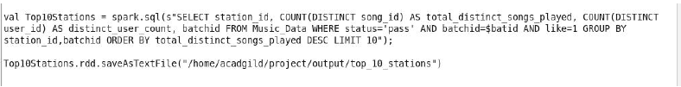

**Output:**

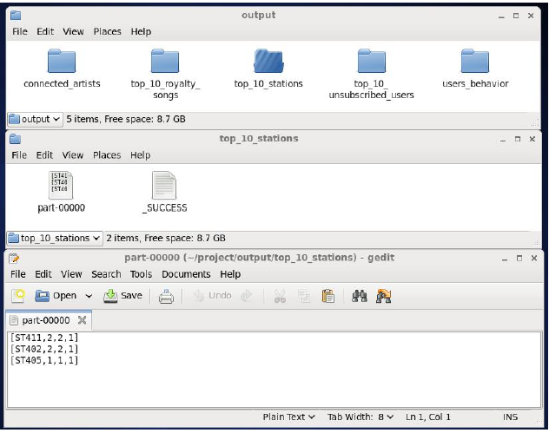

**Problem Statement 2:**

Determine total duration of songs played by each type of user, where type of user can be **'subscribed'** or

**'unsubscribed'**. An unsubscribed user is the one whose record is either not present in **Subscribed_users**

lookup table or has *subscription_end_date* earlier than the *timestamp* of the song played by him.

**Code:**

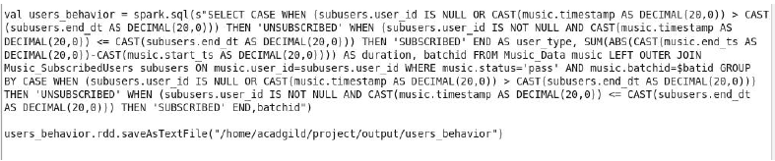

**Output:**

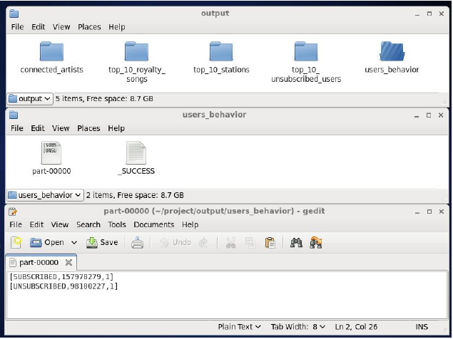

**Problem Statement 3:**

Determine top 10 connected artists. Connected artists are those whose songs are most listened by

the unique users who follow them.

**Code:**

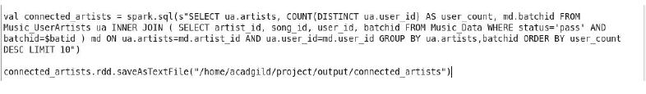

Output:

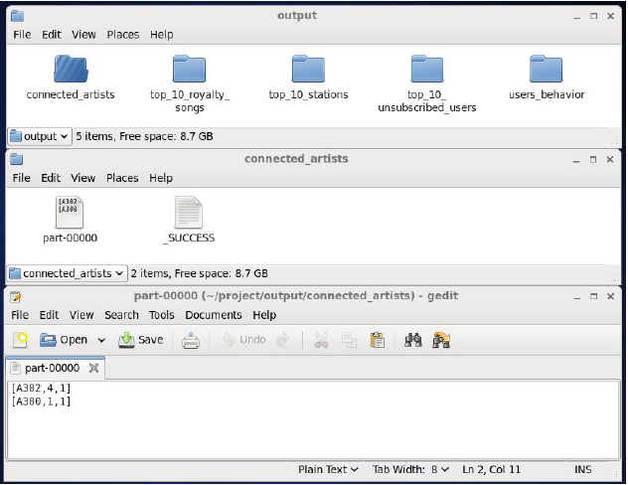

**Problem Statement 4:**

Determine top 10 songs who have generated the maximum revenue. Royalty applies to a song

only if it was *liked* or was *completed successfully* or both.

**Code:**

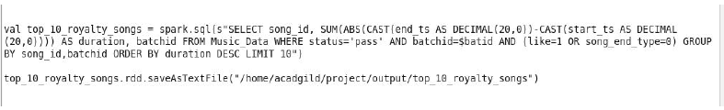

**Output:**

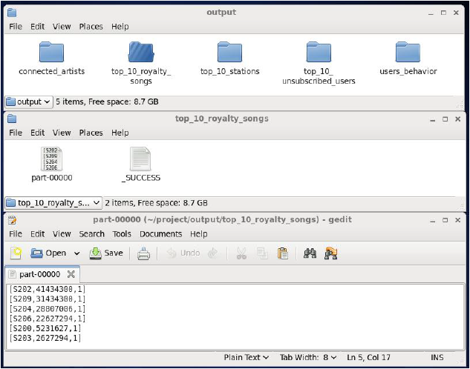

**Problem Statement 5:**

Determine top 10 unsubscribed users who listened to the songs for the longest duration.

**Code:**

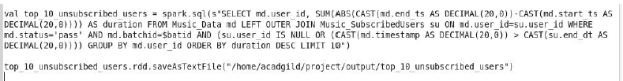

**Output:**

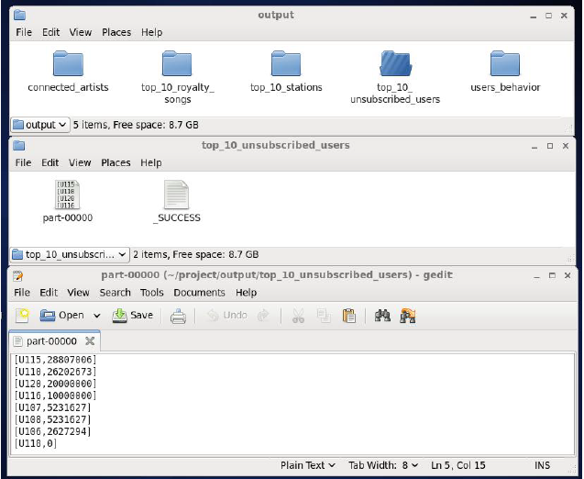

Below is a view of the execution of the above:

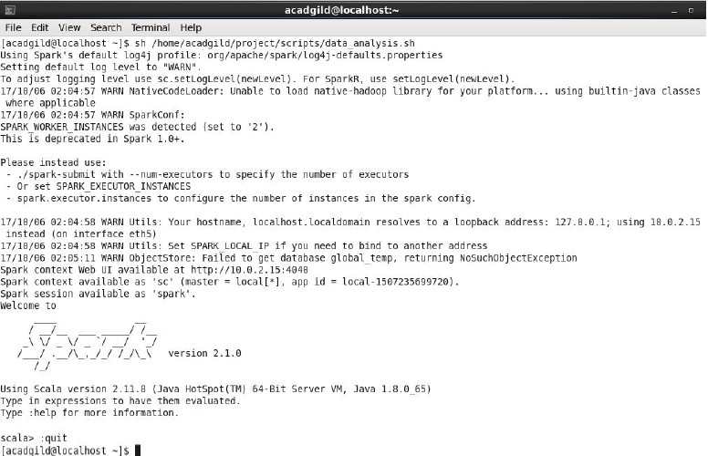

**Post Analysis:**

A view of the log file post analysis.

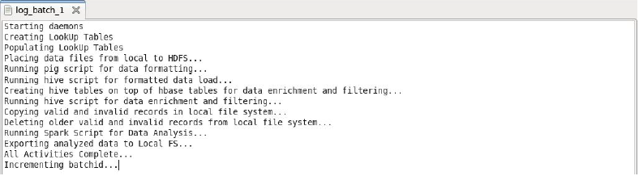

The batchid is incremented from 1 to 2:



A view of the log folder:

